Work Ticket Assignment

MIST 7570 Team Project
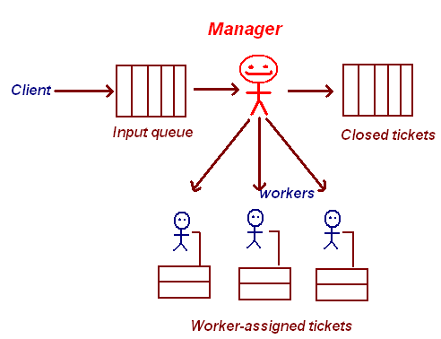
Introduction: in this exercise you will build a simple but functional work ticketing system. The life cycle of a ticket is as follows:
- A client enters a work request, which is placed in the input queue.
- The Manager either assigns the ticket to a Worker, or moves it directly to the store of closed tickets if she judges that there is nothing to be done.
- The Worker to whom the ticket is assigned and the Manager attach annotations to the ticket describing the progress of the work;
- When the Worker decides the
- When the Manager judges that the work is complete, he transfers the ticket to the closed store.
Workers and the Manager must log in to perform actions 2, 3, and 4 above, but the client does not need to log in to submit a request.

Views in this application:
- The index page is publicly viewable and contains forms for logging in and for submitting a work request.
- The response page displays when a user has entered a work request. It politely thanks the user and displays the ticket id and the subject.
- The master ticket view displays a summary of all the tickets, grouped by categories of queued input tickets, active tickets, and closed tickets. The summary displays the ticket number, brief title, and time/date of last activity on the ticket. Each ticket number is a link to the single ticket view for the ticket. This page also contains input controls for closing a ticket or assigning a ticket to a worker.
- The single ticket view contains all the information about a ticket, including all of the annotations made, and a form for entering a new annotation.
- The worker ticket list displays a summary of all the tickets assigned to a particular worker. The summary displays the ticket number, brief title, the time/date of last activity on the ticket, and the most recent annotation on this ticket. Each ticket number is a link to the single ticket view for the ticket.
- The user administration page has forms for creating a new user and changing a user password. Please provide two “password” type input fields to enter and verify the password.
- An error page is displayed if the user attempts to perform an operation for which she or he is not authorized.

Role-based permissions and authentication:
- Only the Manger can see the master ticket view, assign a ticket, or close a ticket.
- Only the Manager or a Worker can view a ticket or add an annotation.
- Only the Manager can create a new user.
- Only the Manager or a Worker can change a Worker’s password. A Worker can only change his or her own password
- In your first iteration, store passwords in the database. In the next iteration, use a message digest algorithm such as SHA-256 or MD5. A user login is accepted if the digest of their input matches the stored password digest.

Logging:
- Please log all requests to a log file, using the log4j logging tools. There will be an eLC exercise on how to do this.

Implementation Hints:
- Start by defining the data model – what entities and attributes for each entity. The JDBC exercise will help with creating the data tables. Don’t forget the foreign keys when entities must be linked to other entities.
- Then “mock up” the Views by writing their HTML with fake data that will be replaced by JSP tags. Use a <textarea> to enter the details of the client’s complaint, er, request.
- Please use PreparedStatements for database access. This class has a getGeneratedKeys() method that can be used to retrieve any auto-generated keys.
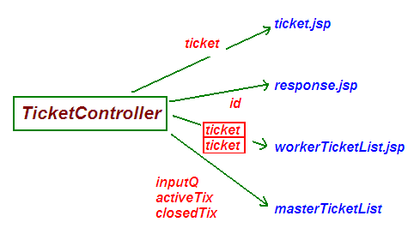
- Do as much business logic as possible in helper classes rather than controllers. In particular, define a class TicketDAO in package tickets.
- You can reduce the complexity of your Controllers by creating multiple Controllers. I used a LoginController to handle logins, a TicketController to handle all the ticket views and edits, and a UserController to handle user updates. That way, each Controller has a simpler logic. Don’t forget to use POST methods for non-idempotent operations and for submitting passwords.
- Make a servlet workflow table of use cases, as shown below.
- Creating high-powered MD5 or SHA-256 digests is amazingly easy, thanks to the Java Cryptographic Extension. The class you need is MessageDigest – this link contains example code as well.
- The digest created by the above step contains a bunch of unreadable characters. Here are some suggestions as to how to convert these to nice hex format.
Use cases for Ticket system example
Use case | Controller | Outcome | Destination
Staff member logs in | LoginController | Manager login | masterTicketList
 |  | Staff login | workerTicketList
 |  | Login fails | Index page
Client enters work request | TicketController | All fields entered | response

Submitting and deploying
This application must be built and deployed on an Internet host, such as an AWS instance, for full credit. Please submit the following design documents in the intial submission:
- Servlet workflow diagram
- Javadocs for your Java classes
- Work breakdown structure, including time estimates and team member assignment for each low-level module. Remember that writing JUnit test code is a work item!

Grading Rubric
You will receive two grades: one for your team, and the other for your personal participation. Your grade will be the average of these two; e.g. if your project works great but y I cannot tell what you did, you will get a 50.) Accordingly, it is important that I be able to tell precisely what each individual student accomplished on this project. This information should be in the form of @author javadoc tags for Java code and individual work breakdown structure entries.
Accomplishment | Points
Spec comments | 10 points
Data model | 10 points
Complete set of JUnit tests, all pass | 10 points
Login process works (hashed passwords) | 10 points
Submitting a ticket works | 10 points
Worker list view | 10 points
Manaer ticket operations | 20 points
Adding and viewing annotations to ticket | 10 points
Controllers enforce security restrictions | 10 points
Total | 100 points

In a real application, you might want to reject any ticket submissions that did not originate from your users’ domain, to prevent your system from being spammed by hackers from Estonia to Tierra del Fuego.

